Daily Notebook & Social Networking Updater

**MCA 6th Semester**

**MCSP-060(Project Synopsis)**

**Anirban Nandy**

**Enrollment No-105057536**

* Table of Contents/Index with page numbering
* Introduction/Objectives

Introduction:

Nowadays social networking is the main trend among us. We like to share whatever is happening with us or around us and follow about others. We want to keep track of every possible thing in our life. Earlier day’s people used to maintain Notebook or Daily Diary to write down about their experiences. Now also we do same things but in different ways. With advent of new technologies we use twitter, facebook instead of maintaining a diary. As all of them are online services we cannot access them without an internet connection and sometimes it takes lots of time to load or query our own posts from the server.

Daily notebook & Social Networking Updater will provide a way to organize our daily notes and status updates for social networking sites. It will allow users to add notes and update it to most popular social networking sites. User can add notes anytime and mark it for update, and then whenever user comes online the pending updates will be uploaded to the destination sites. Users will be able to download the RSS feed of the websites and the Daily notebook & Social Networking Updater will automatically download the feeds and make it available for offline view also. The overview of this software is displayed below in the diagram.

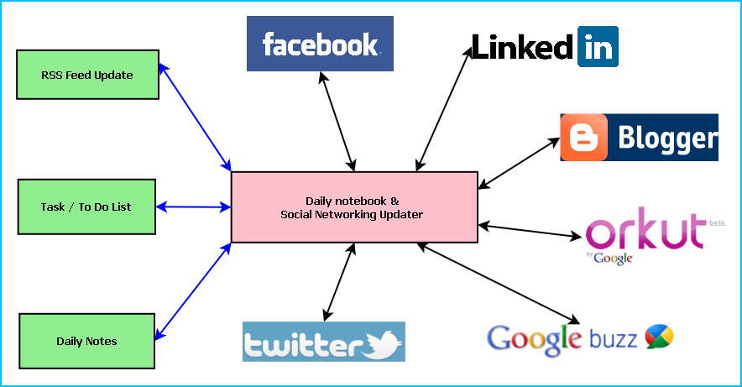

**Figure:** Overview of Daily notebook & Social Networking Updater

Main features of the Daily notebook & Social Networking Updater are:

* Maintaining daily notes
* Updating the status in Social Networking Sites and downloading the RSS feeds

|  |
| --- |
| * Facebook integration * Twitter integration * Google Calendar integration * Linkedin integration * Google plus integration * Google Maps integration |

* Maintaining To Do/Task list
* Reminder/ alarm for scheduled task
* Printing of Notes, To Do & Tasks
* Archiving old data
* Searching Updates

Objective:

* Single solution for updating any social networking sites
* Keeping track of daily activities
* Timely update whenever internet is available
* To simulate similar experience of Daily notebook.
* To be involved with full-fledged software development
* To know about new technologies like .NET, WPF, Facebook, Twitter.
* System Analysis
* Identification of Need
* Preliminary Investigation
* Feasibility Study
* Project Planning & Scheduling:

### Gantt chart

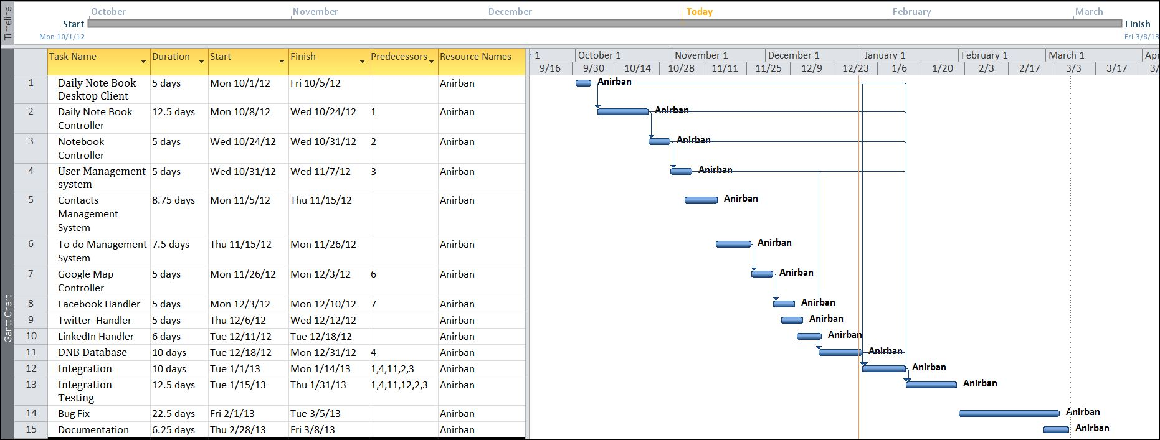

### Tracking Gantt

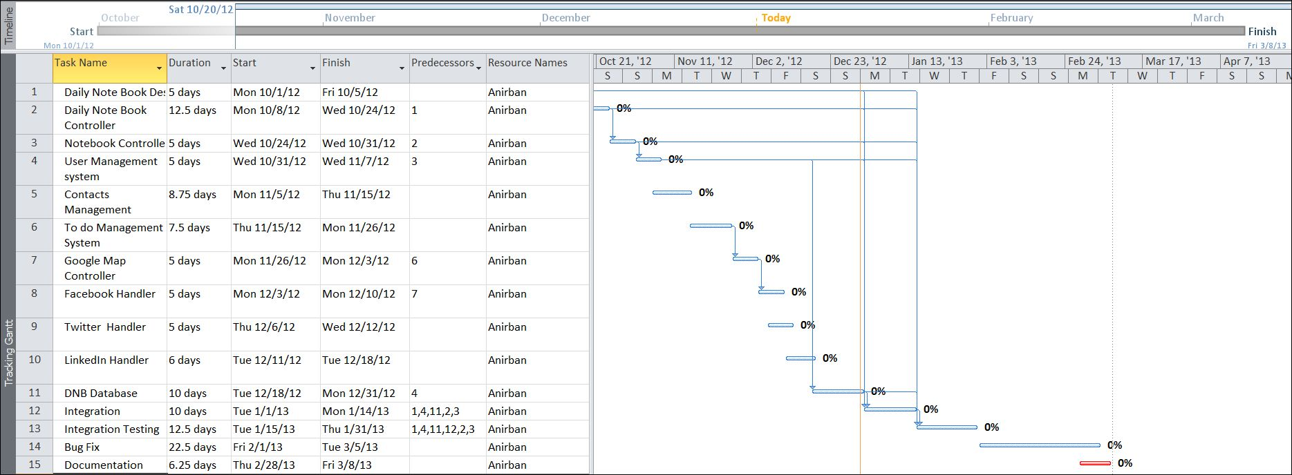

### Pert Chart

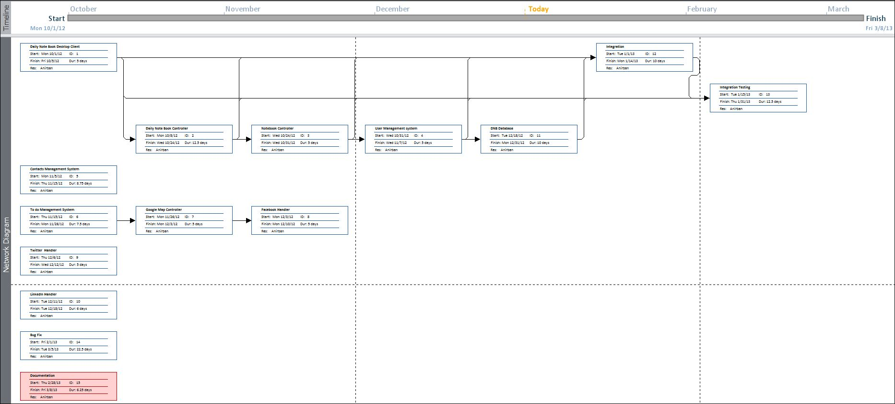

* Software requirement specifications (SRS):

Minimum System Requirement:

* Windows XP (x86) with Service Pack 3 /
* Microsoft .NET 4.0

Recommended System Requirement:

* Windows Vista (x86 & x64) with Service Pack 2 / Windows 7 (x86 & x64)
* Software Engineering Paradigm applied
* Data models (like DFD), Control Flow diagrams, State Diagrams/Sequence diagrams, Entity Relationship Model, Class Diagrams/CRC Models/Collaboration Diagrams/Use-case Diagrams/Activity Diagrams depending upon your project requirements
* System Design
* Modularisation details
* Data integrity and constraints
* Database design, Procedural Design/Object Oriented Design
* User Interface Design
* Test Cases (Unit Test Cases and System Test Cases)
* Coding
* Complete Project Coding
* Comments and Description of Coding segments
* Standardization of the coding

12

* Code Efficiency
* Error handling
* Parameters calling/passing
* Validation checks
* Testing
* Testing techniques and Testing strategies used
* Testing Plan used
* Test reports for Unit Test Cases and System Test Cases
* Debugging and Code improvement
* System Security measures (Implementation of security for the project developed)
* Database/data security
* Creation of User profiles and access rights
* Cost Estimation of the Project along with Cost Estimation Model
* Reports (sample layouts should be placed)
* Future scope and further enhancement of the Project
* Now it will display the text based RSS feeds and link of the multimedia contents. We will display the Multimedia contents like Video, Audio & Image in future.
* To support UNIX / Linux Based Operating systems.
* To Support Mobile Operating systems for Symbian, Meego & Android.
* Bibliography
* <http://en.wikipedia.org>
* <http://msdn.microsoft.com/en-us/>
* <http://www.microsoft.com/en-us/default.aspx>
* <http://www.codeplex.com/>
* <http://stackoverflow.com/>
* <http://www.codeguru.com/>
* <http://www.w3schools.com>
* [www.mysql.org](http://www.mysql.org)
* Appendices (if any)
* Glossary.